skills

people end-user advocacy; teaching and mentoring; continuous focus on team’s success
design thinking & user-experience (UX) research

the point discover and solve real-life problems in the workplace

observations, interviews respectfully elicit users’ perspectives, putting aside my preconceptions

brainstorming guided teamwork to generate creative, collaborative ideas

thinking together drawings and mockups to get everybody on the same page

paper prototypes sketches to convey ideas quickly and help users feel comfortable participating

software prototypes test ideas in reality, find real-life problems, hone in on the most valuable solutions

additional techniques think-aloud studies, storyboards, wireframes, personas, affinity diagrams, contextual inquiry, heuristic evaluation
software architecture

GUI frameworks reusable, extensible, robust, modular, object-oriented, well-documented user-interface components for graphical user interfaces (GUIs)

multi-threaded design support for real-life, asynchronous events from users and networks
computer programming

In the past few years:

languages Objective-C, Node.js, desktop and Android Java, HTML5, CSS, JavaScript, JSON, XML, Bourne shell, regular expressions, SQL

tools Cloud9, Core Data, Confluence, Cornerstone, Eclipse, git, Photoshop, Subversion, Tower, vi, VirtualBox, Xcode

devices iPhone and iPad, Samsung Android phones, BeagleBone Black

operating systems iOS, Macintosh, Windows, Linux

Others I’ve enjoyed 680x0 assembler, BASIC Stamp, C, C++, C#, Gain Momentum, Google Gadgets, Oracle, Perl, PHP, PostScript, PowerTV, Ruby, Ruby on Rails, SQL, Visual Studio, Yahoo! Widgets
employers and clients (details on pages 4–10)

2014 Y Media Labs iPhone app components; technical analysis for design project

2014 Gibson Hardware, software, and paper prototypes including web sites, web servers, iOS/Android apps, joysticks, and physical control panels

2012 BoardVantage iPad, iPhone, and Android clients for a highly secure email- and document-management system

2008 Ricoh Innovations Rapid software prototypes to help clients identify and solve problems revealed by our user-experience (UX) research

2006 Ricoh Americas Corporation Graphical tools for controlling print shops; reusable XML toolkit

2005 NASA Ames and CMU UX research to help scientists and engineers collaborate; software for controlling a robot and correcting the robot’s route

2004 Carnegie Mellon University Graphical tools for searching, analyzing, and playing video; user studies

2002 DeVry Institute of Technology Taught courses in Java, systems analysis, database-driven Web apps

2000 BroadRiver Communications Customized our customer-relationship management (CRM) system; integrated it with telephone switch, operations support, intranet

1997 BellSouth.net Web sites; point-and-click construction kit for e-commerce Web sites

1995 BellSouth Interactive Media Video-on-demand browser and player for interactive television

1992 Information Management, Inc. Macintosh front ends to mainframe-based invoice-editing and credit-verification systems, including a graphical fax viewer

1992 Thomson-CSF (Paris, France) DOS and PostScript quality-assurance reporting tools

education

2006 Carnegie Mellon University Master’s degree in Human-Computer Interaction

1992 Washington University in St. Louis Bachelor of Science in Computer Science
Bachelor of Arts in French
Minor in Anthropology

1991 ESIEE (Paris, France) Computer-science classes in French, at a French engineering school

Professional courses over the years Objective-C, design thinking, Java, SQL, Clarify, Continuus, Intershop, Gain Momentum, MapInfo, Sybase, and more

sample projects (details on pages 12–20)

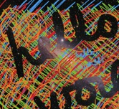 | page 12:  iPad finger-painting app (Objective-C) | 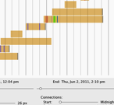 | page 13:  analytics engine  (Java on Macintosh) | 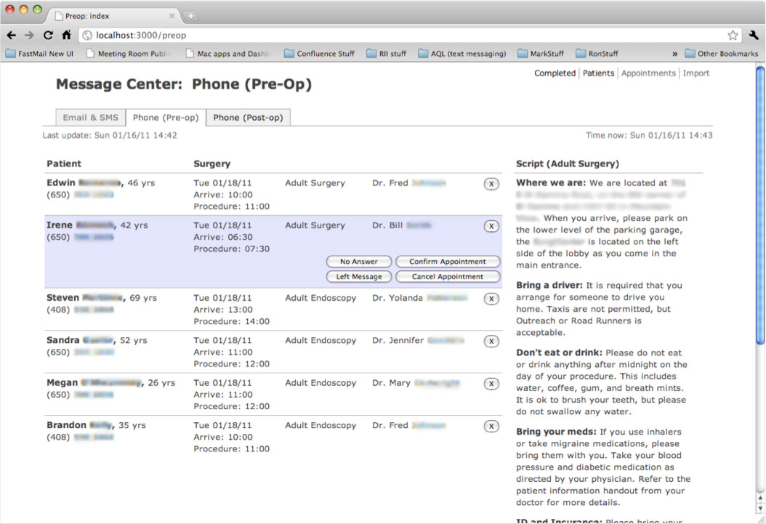 | page 14:  patient notification system  (Ruby on  Rails, CSS, jQuery)
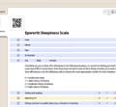 | page 15:  handwriting analysis configuration tool (Java on Windows) | 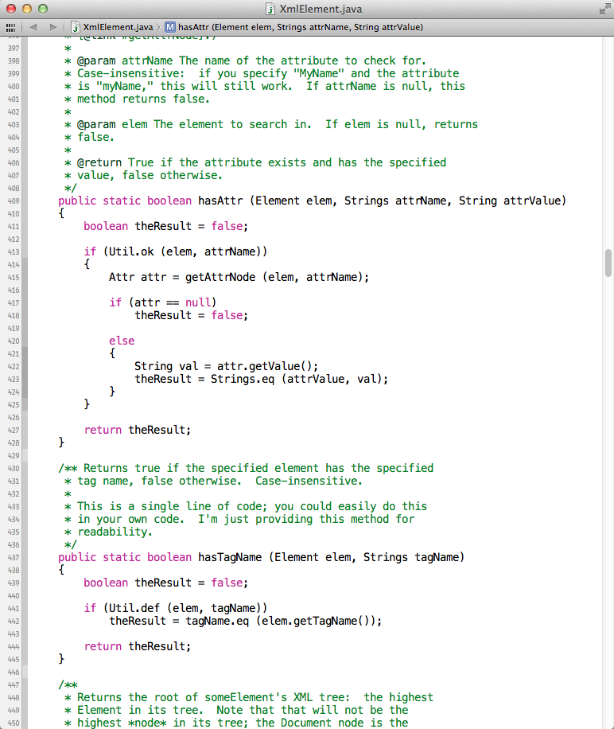 | page 16:  XML toolkit (Java on Macintosh & Windows) | 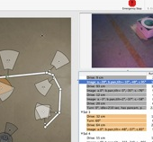 | page 17:  robot controller and POV viewer  (Objective-C on Macintosh)
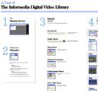 | page 18:  wall-size poster with physical zoom levels  (Adobe Illustrator) | 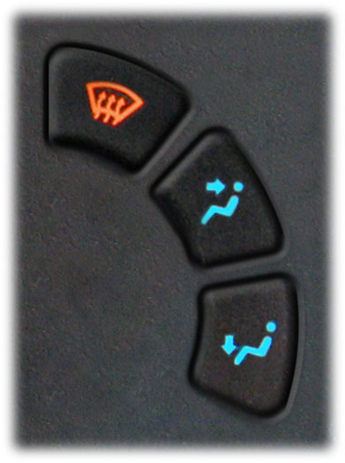 | page 19:  redesigning my car dashboard (Photoshop) | 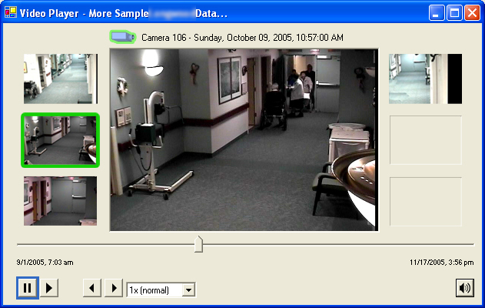 | page 20:  synchronized playback for related videos  (C# on Windows)

section 2
project descriptions
(7 pages)
full-time employment and projects

Senior Software Engineer, Y Media Labs (Redwood City, CA)
2014 Nov–present

Rapidly-growing iPhone design firm. My roles: iPhone engineer and software-architecture consultant. Teams: 5 to 15 people. Languages and tools: Objective-C, Xcode, Charles, Confluence, git, Tower. Hardware and OSs: iPhone (iOS), Macintosh.

Senior Software Engineer, Human Interaction Systems
AREA G (Silicon Valley R&D group), Gibson Brands, Inc. (Redwood City, CA)
2014 May–2014 Nov

Small R&D group in large guitar company. We investigate potential future products, including consumer electronics and musical instruments. I’m the only employee focused on user-interface design and engineering. My roles:
- Build rapid UI prototypes for our embedded systems, including web sites, web servers, and iPhone/iPad/Android apps, making those UIs communicate with other peoples’ modules over command line and sockets
- Write joystick-reading software
- Write PowerPoint storyboard to help us think through the user’s experience resulting from our physical design choices
- Help design physical remote control for home-electronics system
- Participate in architecture discussions for current and planned systems
- Help teammates with JavaScript and socket programming

Teams: usually 2–3 people, with as many as 8 people. Agile techniques (scrum, sprint): Yes. Main languages and tools: Node.js, JavaScript, HTML5, CSS, git, Cloud9, Photoshop, Confluence. Hardware and OSs: BeagleBone, Debian Linux, iPhone, iPad, Android, Macintosh, VirtualBox running Windows XP, prototype hardware from other Gibson departments, third-party home-electronics vendors, and my immediate teammates.

Software Engineer, Mobile group, BoardVantage, Inc. (Menlo Park, CA)
2012 Sept–2014 May

The company builds a single product: a client-server solution with highly-secure email, chat, document viewing, and numerous proprietary features. They have client software for iPad, iPhone, and the Web. I was on the 8-person Mobile team. My roles:
- Design and build user-interface and architectural components for iPhone and iPad, such as the Approvals (voting) tool and the Wall
- First programmer and co-architect on the Android team: researched Android design paradigms, helped port our iOS architecture to Android, helped hire more-experienced Android programmers, and, with them, built the first Android version of our product
- Interview candidates for iOS, Android, and Windows teams
- Mentor teammates as needed

Teams: up to 8 people. Agile techniques (scrum, sprint): Yes. Main languages and tools: Objective-C, Android Java, Xcode, Eclipse, Photoshop, Cornerstone. Hardware and OSs: iPhone, iPad, Android, Macintosh.

Senior Software Engineer, Advanced Business Center, Ricoh Innovations, Inc. (Cupertino, CA)
2008 May–2012 Apr

Customer-research division of an R&D company owned by a global printer-and-camera manufacturer. We performed user experience (UX) research: field research, brainstorming to identify key problems and solutions, paper and software prototypes to hone in on users’ real needs. I was one of 3 engineers building prototypes. My key projects:
- iPhone/iPad software for highlighting and painting on images (Objective-C, Java)
- Analytics engine and GUI for exploring patterns and details in users’ log data (Java)
- Presentation tool for fast, easy screen sharing between devices (Java)
- Desktop “widgets” providing streamlined access to Salesforce.com, Ricoh printers, and other back-end services (Java, JavaScript, Google Gadgets, Yahoo! Widgets, SQL, Excel)
- Web site for helping hospital staff track patient communication and preparedness, and send email and text reminders to patients (Ruby on Rails, jQuery)
- System for analyzing handwritten patient-information forms and letting doctors specify which fields to analyze (Java, XML)

Additional responsibilities: explored and reported on user-interface technologies useful for building these prototypes. Mentored teammates and taught classes in Objective-C, Xcode, Java, Ruby, Rails, and Photoshop. Conducted user interviews. Software teams: up to 3 people. Project teams: up to 8 people. Main languages and tools: AJAX, C#, Flash, Google Gadgets, Java, JavaScript, jQuery, HTML, Objective-C, Ruby on Rails, WindowBuilder, XML, and Yahoo! Widgets. Additional languages and tools: Flex, Facebook (as a software platform), JSP, PaperVision3D, and Zinc. Hardware and OSs: Windows, Macintosh, iOS (iPhone/iPad).

Principal Engineer, Ricoh Americas Corporation (Cupertino, CA)
2006 Aug–2008 May

Research division of a global printer-and-camera manufacturer. Developed graphical user interfaces enabling users control and schedule machines in a print shop; also designed and developed an engine enabling developers to describe those services programmatically, and display their capabilities in a graphical, human-readable way. Developed a reusable library for opening, parsing, editing, and saving XML files, enabling me to use and manipulate XML as an in-RAM data structure instead of writing wrapper classes around expected data types. Additional responsibilities: researched the print-industry standard Job Definition Format (JDF), and taught to teammates; implemented significant portions of a scalable software architecture supporting loosely coupled components; mentored coworkers in C# and Java; wrote a library of reusable, object-oriented components, including a real-time XML-manipulation library the multi-threaded “hot-folder watcher” by which many of our software modules communicated. Teams: up to 5 people. Languages and tools: C#, Java, JDK, XML on Windows.

Student researcher, NASA Ames Research Center and Carnegie Mellon University
(Pittsburgh, PA, and Mountain View, CA)
2006 Jan–2006 Aug

Capstone project for Master’s degree in Human-Computer Interaction

A class during the school semester, and full-time during the summer

Researched, designed, and developed a graphical tool enabling scientists and engineers to collaborate when specifying drive plans for remote, semiautonomous robots. Research included on-site observations and interviews at NASA’s Jet Propulsion Laboratory (JPL) and Cornell University. Team: 8 people. Analysis and design: contextual inquiry, cognitive walkthrough, makestorming, paper prototyping, wireframes, and extensive user testing. Languages and tools: Java, Objective-C/Cocoa, Subversion on Macintosh. http://www.hcii.cmu.edu/M-HCI/2006/NASAProject/

Research Programmer, Informedia research group, Carnegie Mellon University (Pittsburgh, PA)
2004 Aug–2006 May

My full-time job, while earning a Master’s degree part-time

Designed and developed user interfaces and supporting architectures for the Informedia Digital Video Library (IDVL), a video-search, -display, and -analysis platform. Conducted user studies for our participation in the annual TRECVID video-information-retrieval contest. Mentored new developers as needed. Projects:
- Extended the UI for the IDVL Client, our main-line search application
- Rearchitected the IDVL Client to have a true object-oriented architecture
- Designed and built the Video Structure Editor, for tying individual video frames to real-life, human events
- Designed and built the CareMedia Video Console, for viewing multiple time-synchronized videos simultaneously
- Designed and built numerous reusable software components: window-creation architecture • window-messaging architecture • pop-out window tabs • joystick-like 2D scrollbar • collapsible window sliders • database-aware radio buttons • DirectShow video-playing wrapper • n-speed video player • “floor plan” view for controlling multiple time-synchronized video cameras • search-history tracker and replayer • “advanced search” window helping the user map GUI controls to search-engine shortcuts

Teams: up to 4 people. Languages and tools: C#, Oracle SQL, SourceSafe, XSD, XML on Windows 2000/XP.

Publication: Christel, M. G. and Conescu, R. M. 2005. Addressing the challenge of visual information access from digital image and video libraries. In Proceedings of the 5th ACM/IEEE-CS Joint Conference on Digital Libraries (Denver, CO, USA, June 07–11, 2005). JCDL ’05. ACM Press, New York, NY, 69–78. DOI=http://doi.acm.org/10.1145/1065385.1065402.

Instructor, DeVry Institute of Technology (Long Island City, NY)
2002 Feb–2004 Jul

Taught courses in designing and building database-driven Web applications, as well as courses in Java, systems analysis, and object-oriented design. Consulted numerous students, now professionals, on their personal and professional web sites. Languages and tools: ASP, CSS, Java, JavaScript, SQL, XML on Windows.

Member of Technical Staff (“The UI Guy”), BroadRiver Communications (Alpharetta, GA)
2000 Feb–2001 Aug

Lead UI engineer at an Internet-based telephone company. Served on architecture team; supported production systems; administered version-control system; learned Clarify (a customer-relationship management tool) and taught to other developers; mentored new UI programming staff. Projects:
- Customized and extended Clarify’s UI and database, deploying it as a front end to our 12-machine operations-support system, trouble-ticketing workflow engine, corporate Intranet, and voicemail system
- Created Clarify-based one-click front end to our telephone-service provisioning system
- Designed corporate software-development process
- Helped redesign corporate Intranet
- Rewrote portions of billing system

Teams: up to 6 people; one extended team of 22 people. Languages and tools: Clarify, ClearBasic, JSP, HTML, SQRIBE, Oracle SQL, Continuus on Windows and Unix.

GUI engineer and Technical Team Lead, BellSouth.net (Atlanta, GA)
1997 Nov–2000 Feb

Numerous roles building Web sites and Web applications, often as lead engineer. Performed extensive cross-browser compatibility testing on everything. Mentored new developers. Specific projects:
- Lead developer for the BellSouth Site Builder, an e-commerce web-site construction kit for non-technical customers
- Lead developer for BellSouth’s “Business Gateway,” a business-products web site
- UI Lead on team integrating our trouble-ticketing system and our interactive voice-response (IVR) system
- Provided UI guidance to architecture team for BellSouth’s Virtual Private Network offering
- Built web pages for numerous BellSouth web sites and projects
- Built web pages and mall kiosk pages for Ernie the Talking Elf

Teams: up to 5 people; one extended team of 15 people. Languages and tools: HTML, Informix SQL, Intershop, Perl, vi macros on Windows and Unix.

Multimedia Developer, BellSouth Interactive Media Services (Atlanta, GA)
1995 May–1997 Nov

Designed and developed major portions of the BellSouth Navigator, a video-on-demand browser for interactive TV—like what you see in most hotel rooms, these days—including its user interface, software architecture, and integration with the back-end video server. Enhanced and debugged Gain Interplay, the Navigator’s embedded-system run-time engine and language parser. Teams: up to 3 people. Languages and tools: awk, C, csh, Gain Momentum, Gain Interplay, make, regular expressions, Remedy, sh, SNMP, tcl/tk on Windows, Unix, and PowerTV.

GUI Developer, Information Management Incorporated (Atlanta, GA)
1992 Sep–1995 May
- For AirTouch Cellular: Added Macintosh-based credit-checking features to AirTouch’s mainframe-based customer-management software. Team: 2 people. Blacksmith, Omnis 7² on Macintosh.
- For the Norfolk Southern Corporation: Developed significant portions of a Macintosh front end to Norfolk Southern’s billing system, enabling them to view customers’ faxes on the same screen as their mainframe-based billing data and internal project assignments. Sub-projects: waybill editor; fax viewer; database-driven help system; numerous reusable, object-oriented GUI components. Team: 3 people. Languages and tools: C++, MacApp, Sybase SQL, and an in-house screen-scraper on Macintosh and Unix.

Intern, Thomson-CSF (Paris, France)
1992
Jan–Jul

Designed and built software to track and analyze the quality of subcontractors’ software. Languages and tools: PostScript, object-oriented Pascal on Windows 3.1 and HP LaserJet IIIsi.
professionally relevant projects from graduate school (Carnegie Mellon University, 2004–2006)

design and development

Robot dashboard
2005
Sep–Dec

NASA’s Jet Propulsion Laboratory; Carnegie Mellon’s Robotics Institute

Independent study; part of the PROSPECT project

Designed and developed tools to monitor the status of remote, semi-autonomous robots, store that status in a future-compatible format, and display the status using standard-looking graphics, such as an “artificial horizon,” a fuel gauge, and blinking alarms. Network-friendly: any component can “die” without affecting the others. Team: 6 people. Languages and tools: C#, Flash/ActionScript 2.0, XML on Windows XP.

Publication: E. Halberstam, L. Navarro, R. Conescu, S. Mau, G. Podnar, A.D. Guisewite, H. Brown, A. Elfes, J. Dolan, and M. Bergerman, “A Robot Supervision Architecture for Safe and Efficient Space Exploration and Operation,” Tenth Biennial International Conference on Engineering, Construction, and Operations in Challenging Environments: Earth & Space 2006 Conference, ASCE, March, 2006. http://www.ri.cmu.edu/pubs/pub_5233.html

Tactile-feedback vest and armband — “seeing-eye vest” for the blind
2005
Mar–Jun

Project for “Wearable Computing” class; followup as independent study

Designed and developed prototype of a cap and vest that attempted to determine the distance to objects around the wearer, and represent those distances as vibrations on the wearer’s chest and abdomen, providing a low-resolution, tactile “display” of the objects around the wearer. Followup project involved a higher-resolution, flexible cushion, instead of a vest, that could be placed against the abdomen, arm, neck, or head. Languages and tools: BASIC Stamp; custom hardware from Radio Shack and Parallax components.

Video-structure editor
2004
Nov–Dec

Project for “Software Architectures for User Interfaces” class and for my employer, CMU’s Informedia research group

Designed and developed a graphical editor enabling the user to load 10,000+ data points generated by a video parser, play the video snippets represented by those data points, and combine those data into higher-level, human-usable events (such as “John walks down the hallway”) via an easy-to-use drag-and-drop interface. C#, XML on Windows XP.

Custom scrolling environment
2004
Sep–Oct

Project for “Software Architectures for User Interfaces” class

Designed and developed a finite-state-machine interpretation of buttons, scrollbars, and a window’s scrollable areas. Java, XML on Macintosh.

design

“Squēz” Music Player for Moms
2006
Mar–May

Project for “Interface and Interaction Design” class

Researched and designed a portable music player affording extremely simple, tactile ways to play music and share music with one’s children. Team of 3 people.

Cell phone search/mapping tool
2006
Feb–Mar

Project for “Interface and Interaction Design” class

Researched and designed a cell-phone interface enabling users to search for coffee shops, sort them by distance and available food, and display textual and graphical directions to get there. Team of 2 people.

Car airflow control switches
2006
Jan–Feb

Project for “Interface and Interaction Design” class

Redesigned the physical control in my car that enables the user to change the direction of airflow from the heater, air conditioner, and defroster. Replaced the existing dial, containing a counterintuitive mapping of airflow directions to physical space, with a set of toggle switches that conform to both the shape and orientation of the human hand and the physical locations of the vents in the car.

“Informedia” poster and user-interface tour
2005
Apr–May

Project for “Mapping and Diagramming” class and for my employer, Carnegie Mellon’s Informedia research group

Arranged approximately 25 windows from a complex search tool into a poster showing how to use each window, a normal sequence in which to use them, and examples of the content used in each window. Contained three levels of information, visible at 10 feet, 6 feet, and 1 foot away.

Cozy wired jacket
2005
Jan–Feb

Project for “Wearable Computing” and “Mapping and Diagramming” classes

Designed a warm, fuzzy, fall/winter coat containing a cell phone, a heater, and arm- and waistbands that become snug when the air temperature drops.
donated and personal projects

Volunteer mentor, CoderDojo
2013 Sep–present

Volunteer mentor with an organization that helps teach computer programming to youth, ages 7–14. Language and tools: Lua, Corona, and Scratch, on Mac, PC, iPhone, iPad, and Android.

iPhone app for dog-rescue service
2012 Aug–present

iPhone client for a web site designed to help abused dogs find better homes. Team of 2 people. Objective-C.

Leap Motion-based sign-language interpreter
2012 Nov–2013 Feb

Consulted on and developed a prototype for a gesture-based sign-language interpreter. Team of 2 people. Java, Objective-C, Leap Motion hardware prototype.

iPhone music player
2012 Apr–present

Developed a prototype iPhone app enabling me to explore, organize, and play music in ways that feel more flexible and natural to me than other iPhone-based music players I’ve tried. Objective-C.

PACTBank on-line banking prototype
2007 Dec–2009 Jun

PACTFund, a community-driven venture capital fund

Consulted on and developed a prototype for an on-line bank that enables volunteer hours to be used as currency. Team of 2 people. Ruby on Rails.

Emergence Conference web site
2006
Jun–Jul

Project for the 2006 Design Conference at Carnegie Mellon University’s School of Design

Consulted on and developed the interface between the Emergence conference web site and their back-end credit card processing system. Team of 3 people. HTML.

Print Lab project-submission web site
2005
Sep–Nov

Print Lab, Carnegie Mellon University School of Art

Consulted on and developed a file-uploading and project-registration site. Team of 2 people. PHP, HTML.

Data-Driven Flash Class
2005 Oct

Guest lecture given in the regular Flash/ActionScript class taught by Carnegie Mellon’s School of Design

Designed and taught a 3-hour, example-driven curriculum, illustrating to non-programmers how to read XML-based, potentially dynamic data into Macromedia’s Flash and display it. Flash/ActionScript 2.0, XML.

section 3
graphical portfolio
of selected projects
(9 pages)
- iPad painting app

2012. For the Advanced Business Center, in Ricoh Innovations, Cupertino, CA.

The project: investigate whether we could help people work more effectively by drawing on top of images they chose.

My contribution: the iPad/iPhone app. Heavily multithreaded and graphics-oriented. Can transmit still images, live video, and web pages to other users, and can receive stills and video. Lets users draw on top of selected images, and temporarily highlight portions of those images. Fully asynchronous, network-friendly, multithreaded; it feels fast, even when there’s a lot going on. Invented various techniques for giving the iPhone and iPad a similar look and feel, sharing resources whenever possible, while supporting a highly customized, non-standard UI. Taught Objective-C and this app to several coworkers, at various levels of detail. I learned Objective-C for this; this was my first iOS app.

These screen shots show that my app lets people draw high-resolution vector graphics on top of a background photograph, by pinch-zooming into the picture, and drawing with a finger or a stylus:
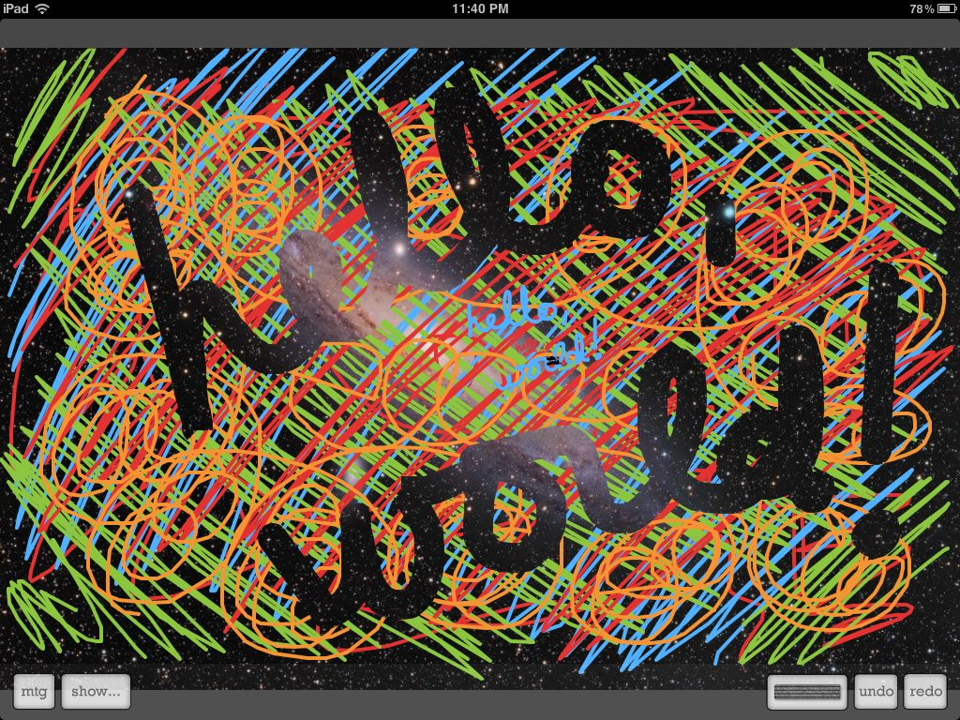
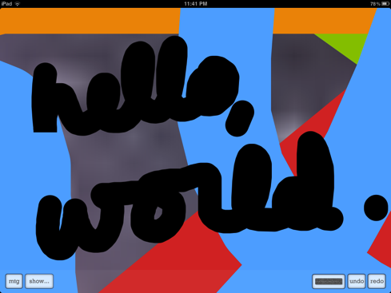
- Java analytics tool

2010. For the Advanced Business Center, in Ricoh Innovations, Cupertino, CA.

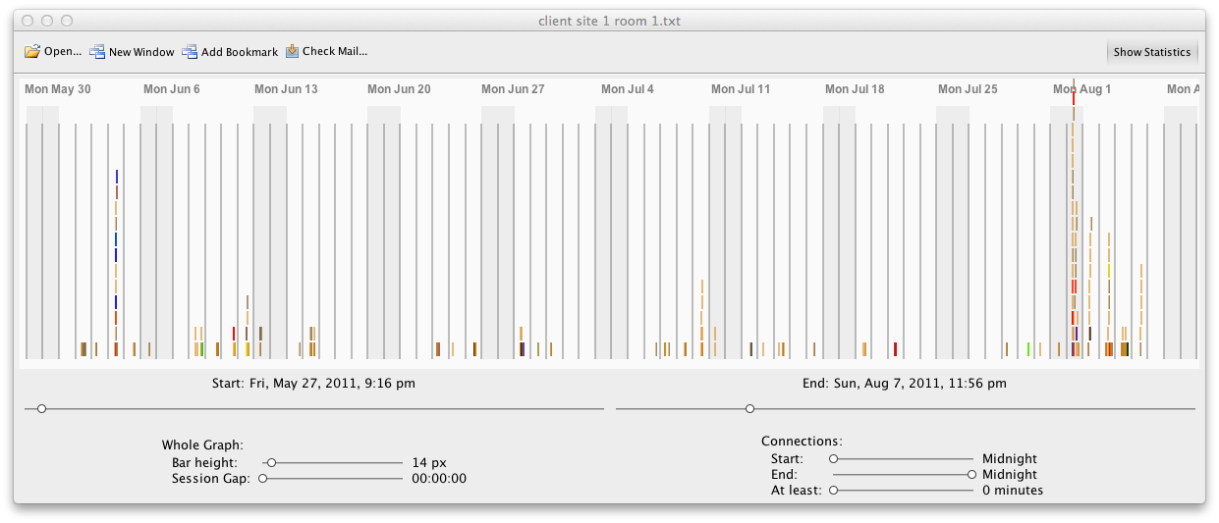
The project: experiment with whether seeing user behavior in a system, graphically, can help us learn about those users’ needs, and thus build better tools during the same project or future projects. Also helped us gain insight into a specific real-life system we had built for a previous project.

My role: built a Java program that lets an analyst view all activity from a client site, as represented in logs from that site, in a graphical timeline. You can use the mouse wheel to zoom into or out of the timeline; you can see several years at a time, or zoom in to see only a few seconds at a time. This lets the analyst both see patterns of user behavior over time, and very rapidly zoom in to see specific user actions. The tool also offered statistics about the interactions in the current view.

In addition, I added the logging facility to a production system that was not originally designed to log end-user events. I then evolved those capabilities in-place, guided by our anthropologist, until the tool helped him understand the real-life stories of the people represented on the graphs. As a result, the tool is both forward- and backward-compatible: it displays data from the oldest log files, and yet let me evolve the logging format as I understood the analyst’s storytelling needs.

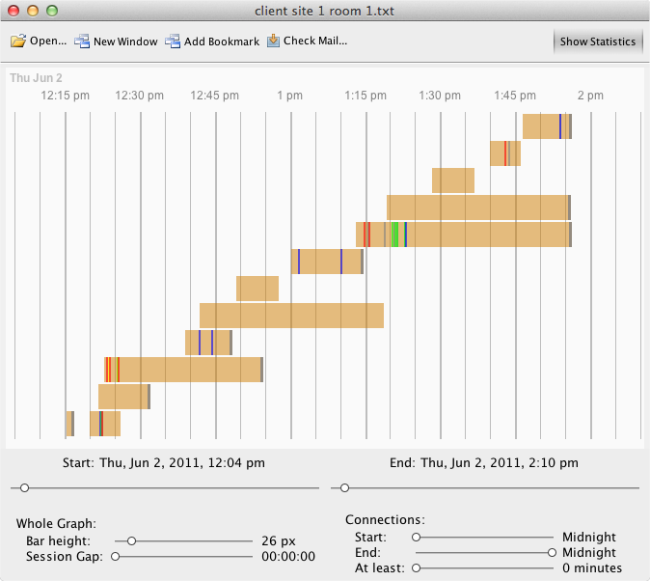
Here’s an example of how we use the tool. From the graph above, it looks like early June and early August
were both busy times at this client site. That lets us ask: why? Is there a periodic business activity, or were those just randomly-busy weeks? Either way, what opportunities are there to support people during those times?

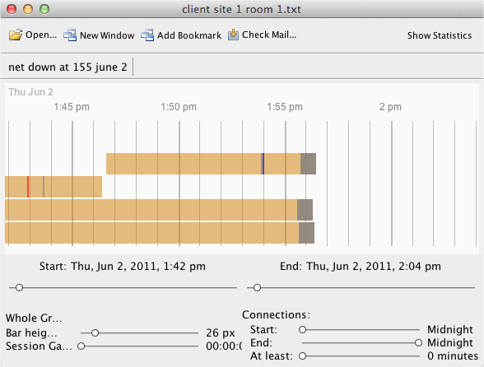
Let’s zoom in on that first spike, on June 2. It seems to have been a single 2-hour meeting, with a bunch of people working together.
But wait — at the end of the meeting, 3 people were disconnected, within the same span
of 15 seconds. Why?
What was their experience of that situation?

By themselves, the graphs don’t answer questions for us. Instead, they raise questions, showing us where to look for interesting, real-life, human situations. Combined with interviews and on-site observations, that lets us find how we can serve people better, and maybe even make money doing it.
- patient-communication system

2009. For the Advanced Business Center, in Ricoh Innovations, Cupertino, CA.

The project: explore whether a hospital could reduce costs by proactively contacting patients before surgery. For example, certain types of surgery cannot be performed effectively if the patient chews a single piece of gum during the preceding 12 hours. For the hospital, this means rescheduling staff, doctors, anesthesiologists, and the surgery room; for the patient, this means rescheduling days off from work and arranging to be picked up after surgery.

My contribution: with a coworker, built a system that:
- sent the patient an email 2 weeks before surgery
- sent the patient two text messages, 1 week and 2 hours before surgery
- prompted hospital staff to call the patient, and provided a script
- let the staff member record the results of the contact, so that another staff member could follow up if necessary

Also taught my coworker Ruby on Rails, which I’d learned on my own.

A representative screen shot:

Record results of this phone call with this patient

Guides staff through today’s phone calls

What to discuss with this patient, based on the patient’s age and type of surgery

Lets staff error-check emails

and texts before they get sent
- electronic analysis of paper forms

2008. For the Advanced Business Center, in Ricoh Innovations, Cupertino, CA.

Project: enable patients to fill in patient questionnaires by hand; enable doctors to electronically specify which parts of each handwritten form they would receive in a report; enable doctors to then scan in many patient questionnaires and receive an aggregate report of patients’ answers.

My role:
- Build a graphical user interface enabling doctors to specify what fields to receive in the report.
- Build a parser to convert an Adobe InDesign file, containing the original questionnaire, into a set of pages and coordinates, so that I could display checkboxes and other fields on top of the graphics of the original form. This let a professional designer lay out the form, and let the user feel as if he were editing the original form.

A sample screen shot:

Source image from the original questionnaire

The app, in Java

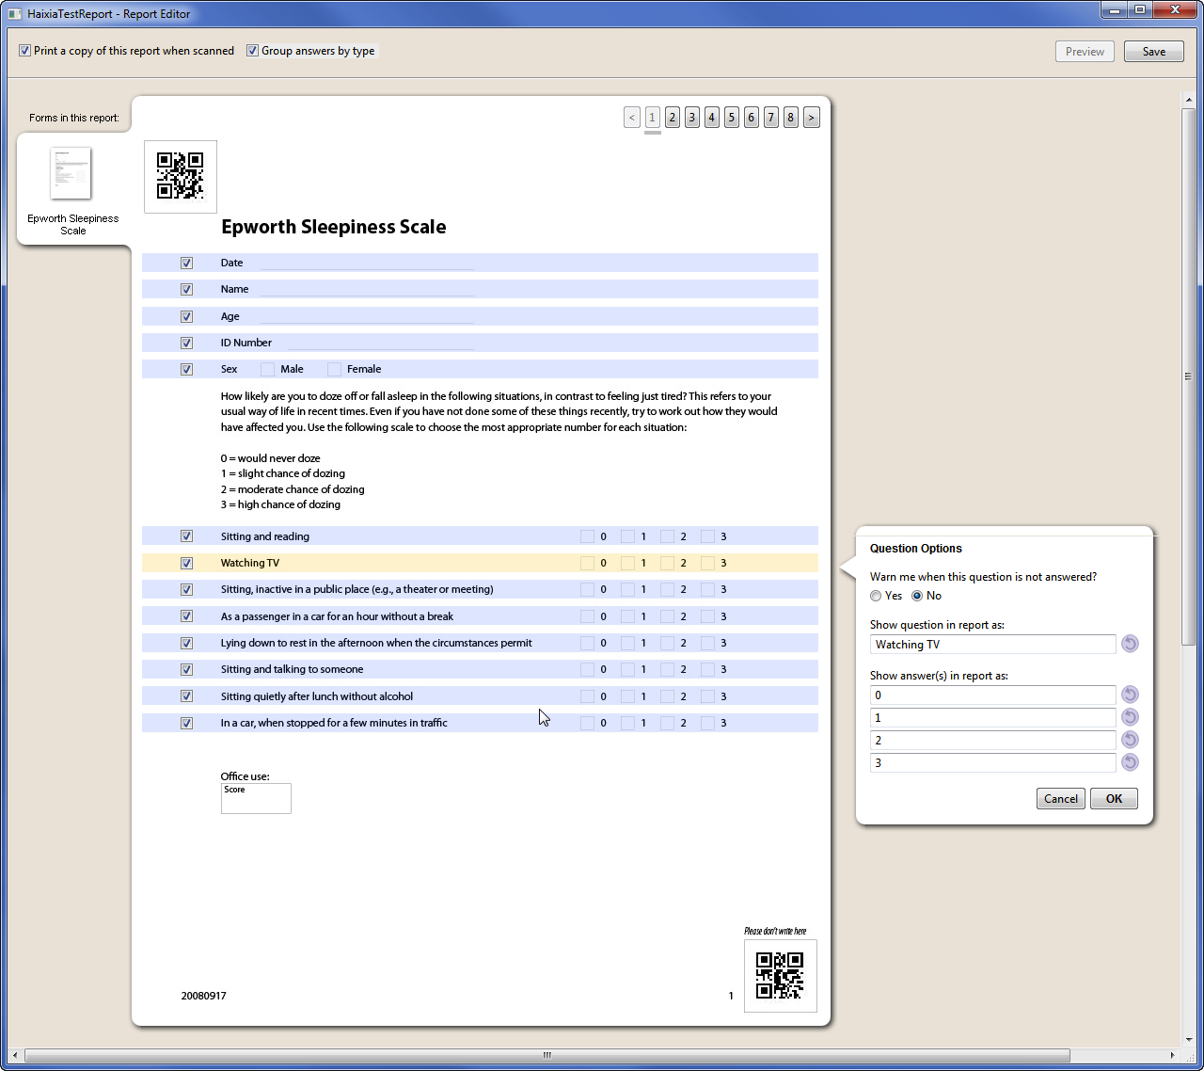

Doctors can specify reporting criteria for each question in the questionnaire

Checkboxes are overlaid in the correct locations

Pages, detected by the parser; the doctor can navigate to these pages
- XML toolkit

2007. For Ricoh Americas Corporation, Cupertino, CA.

The problem: for my main job, I was building print-shop control software. We wanted to use “JDL,” the print industry’s standard Job Definition Language, as the storage format. The standard was evolving rapidly, changing every few months. This meant that if I created Java variables to access the fields in the XML file, I’d have to rewrite that code every time the standard changed.

The solution: use XML as my in-RAM data structure. Initially an experiment, but it worked very well, so we kept it. I built a library that could search through XML files and return specific fields—variables or their values—without knowing or caring where those fields were located. I ended up making a library designed to be readable, extensible, and usable by myself or other programmers. It’s designed so that a number of complex processes and decisions can be accomplished with a single, readable line of code, because I had numerous situations where I had to cascade those processes and decisions. The functions in the library are named so that they alphabetize well when they appear in pop-up menus in NetBeans or Eclipse. The functions never throw exceptions, and almost never return null, so that the result can always be used safely. I ended up using that library for various projects during the next 3 years, at two divisions of Ricoh.

Code sample, showing my writing and documentation style:

- robot control software and research

2005–2006. Capstone project for my Master’s degree. First 5 months at Carnegie Mellon University (Pittsburgh, PA); last 3 months at NASA Ames Research Center (Mountain View, CA), all working for the Human-Computer Interaction group at Ames.

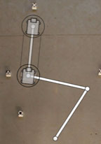

Specifying a drive plan.

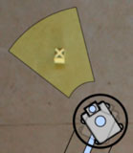

Specifying a photo to take.

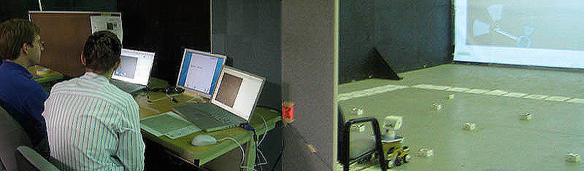

The lab: testers on the left, robot and targets on the right. The floor of the lab serves as “Mars,” a terrain containing scientifically-valuable stuff to analyze. The brown background image in our software is an overhead photograph of floor of the lab, just as Mars mission scientists use satellite images of Mars to plot the robot’s trajectory.

The problem: help NASA cut costs on robotic missions by identifying ways to help improve collaboration between scientists and engineers. We focused on two areas: telling a robot what to do, and correcting for the fact that a robot doesn’t always achieve what you want. Both of these issues involve communication (and miscommunication) among scientists and engineers, and provide an opportunity for their goals to come into conflict.

The solution: an app that enabled a “scientist” and an “engineer” (our test users) to specify a path instructing the robot to drive, turn, take pictures, see those pictures when they come back from the robot, and evaluate whether those pictures contained scientifically valuable information. Sample screen shot:

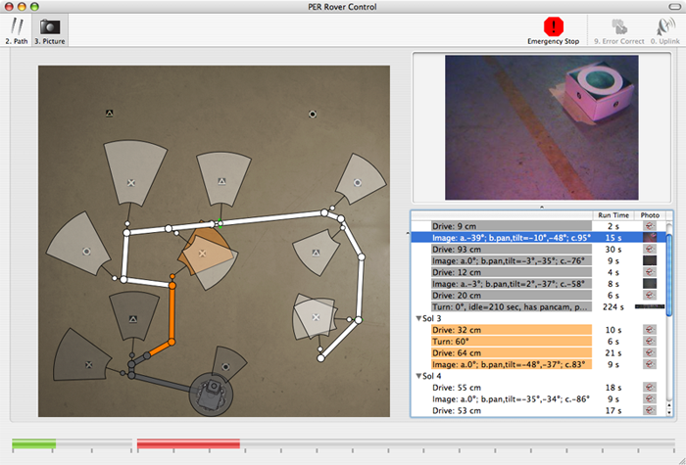

The software also enabled the team to look at the images from the robot’s panoramic camera after it finished executing a set of instructions, attempt to determine where the robot actually ended up—which was frequently different from where they’d attempted to tell it to go—and replan their route based on the newly-discovered location of the robot.
- instructional poster with physical zoom levels

2006. For a design class and for my employer, the Carnegie Mellon University Informedia Video Lab.

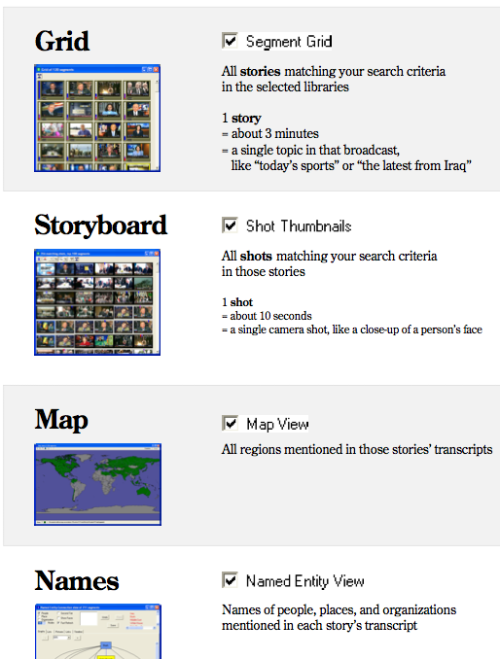

Focus on the middle of the poster, at zoom level 2 (standing 3 feet away).

An instructional poster describing the tools available in our flagship video-search engine. The poster has 3 levels of detail, designed to be visible from 10 feet away, 3 feet away, and 1 foot away; as you walk closer to the poster, you see more detail about the features in your physical field of view. The lowest level of detail (10 feet away, shown below) is intended to show the overall flow of how to use the app; hence the huge numbers, indicating the intended sequence of steps. The next level (3 feet away, shown at right) shows specific features available in the app: the names of windows, the controls you use to invoke those windows. The highest level of detail (1 foot away) describes examples of those features, and lets you resolve details about examples in the screen shots shown on the poster.

I printed the poster at about 5 feet wide by 3½ feet tall:
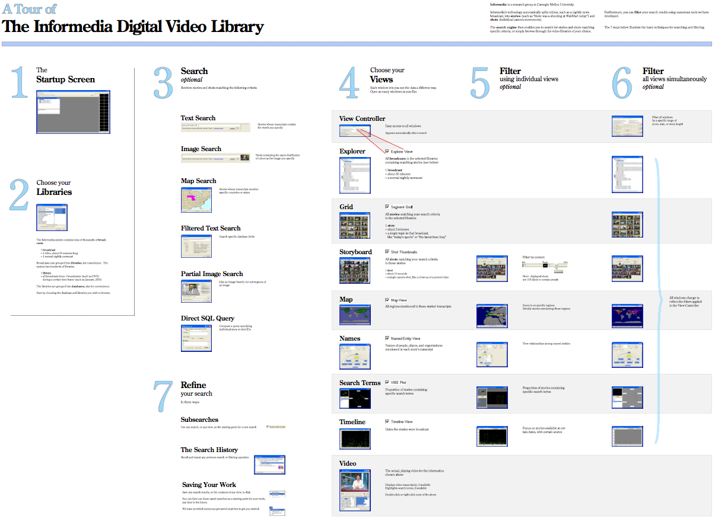
- proposed redesign for a physical control in my car

2006. For a design class, “Interface and Interaction Design.”

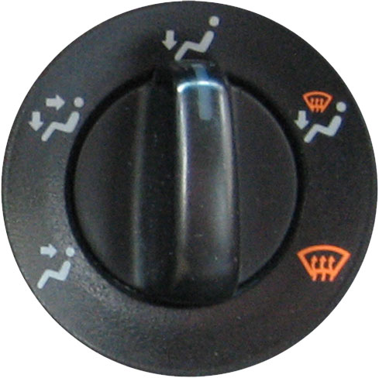

The original (current) airflow dial in my car.

My proposed replacement. Button positions mimic both the physical direction of airflow and the natural curve of the fingers of my right hand.

The project: choose something in the real world that needs to be redesigned, and redesign it.

What I did: reenvisioned a particularly frustrating user experience, and the matching user interface, in my car. My car has a dial (shown at right) that directs the hot or cold air to different locations. It took me years before I learned to use this control subconsciously, automatically, while driving, because I find it so counter-intuitive. For example, to direct air toward my feet (downward), I have to point the control toward the sky (upward).

Instead, I proposed a control I mocked up (shown at right). Features:
- The positions of the buttons correspond to the direction of airflow. The topmost button sends air toward my head, the middle button sends air toward my face, and the bottom button sends air toward my feet.
- The buttons are curved, mimicking the curve of my fingers as I reach my right hand toward the control, in the center console.
- As an interesting side effect, the new controls turned out to be “checkboxes”—independently-selectable buttons that would tell the car to blow air toward my head, face, and/or feet. That would be nice.

Here’s the poster:

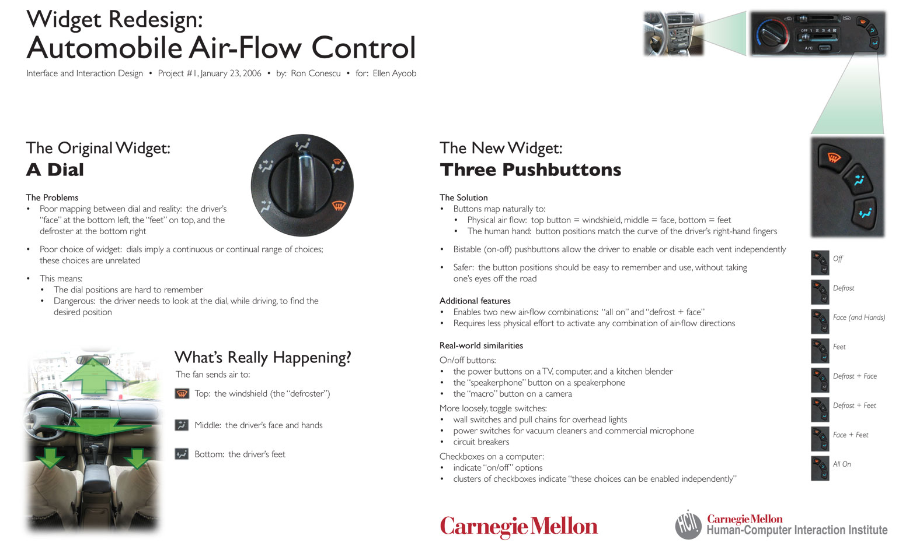
- multi-video player

2005. For the Informedia Research Group, Carnegie Mellon University, Pittsburgh, PA.

Project: An elder-care facility had installed video cameras in the hallways, in an attempt to help identify danger to patients before the danger occurred—for example, an elder tripping, falling, and breaking a bone, or elders becoming angry and striking each other. The facility partnered with Carnegie Mellon University in the hopes that intelligent software, applied to the images from the cameras, could alert staff to potential problems.

Given the locations of the video cameras and a video-feed file from each, I built a video player that let people observe what was happening in a given hallway or room from different angles. I also built a floor plan of the facility on which you could edit the locations of the various video cameras.

